Paramyth
for violin, clarinet, piano, computer

by Yannis Kyriakides

Programme Notes:
The 'Bluebeard' tale appears in many variations around the world, the central theme revolving around a bride who having recently married is subsequently tempted to discover a horrific secret behind the forbidden door. The most well known example is of course Bela Bartok's opera Duke Bluebeard's Castle, which takes it source from the French 17th cenruty writer Charles Perraut. The fatal dangers of feminine curiosity have of course had other sources, Eve, Pandora, Psyche and Lot's wife are all examples of mythical women whose curiosity exacted dire consequenses. What is perculiar in the bluebeard legend and what makes it an intruiging tale, is that the motive is never clear why Bluebeard entrust the bride with the key that will reveal his horrific past.

I was surprised to stumble on a Cypriot variation of this in a collection of oral folklore recordings made in Cyprus by the Peloponnesian Folklore Foundation. Under the title of 'To Parymithi tou Vasilea' (The King's Tale), a recording made in the late 70's of a woman from Potami, Athinoula Christou Kyriakou, tells the story of a king who under bizarre circumstances marries his daughter to satan, who takes her to his underground castle where she enters the 100th 'forbidden' room to find dead bodies and half eaten carcasses of animals. I have no idea how this variation of the story with its stange twists came to be told by this woman from Potami, there seem to be both mythological and Christian resonances in it. The tale follows the classic patterns of narrative, having discovered the room, she is subsequently saved by seven brothers, one of whom she marries in the end; they live happily ever after.

In the composition, I use the recording of her speaking voice, stretching out the vowels with computer synthesis until it seems that she is singing the story. The instruments accompany, amplify and elaborate this telling. Towards the middle of the piece her voice almost becomes frozen, the speed of delivery slows down to zero, at the point of the narrative where she opens the secret door. In my interpretation of the story I leave them just after this point where to comfort the young bride after this revelation, the devil dresses up in her father's and mother's clothes. It's an incomplete story but I found it a touching moment to leave the narrative unclosed, for musical purposes at least we do not need the cavalry to come to the rescue.

Paramyth was commissioned by the Pharos Arts Foundation for the 2nd International Contemporary Music Festival 2010, Nicosia, on the occassion of Cyprus's 50th Anniversary of independance. With additional funding from the NFPK+, The Netherlands.

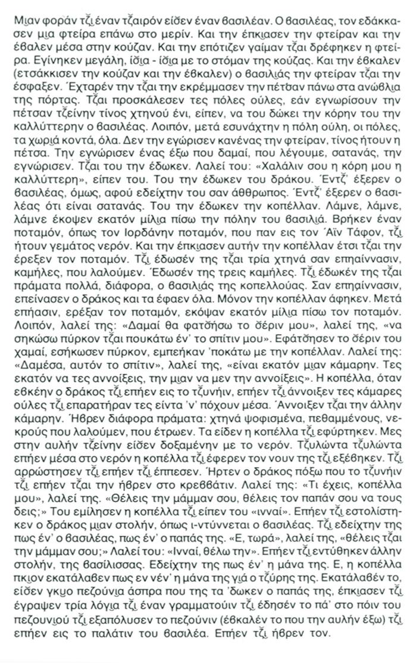

Text:
As told by Athinoula Christou Kyriakou in Greek.
Translated by John Leatham

Once upon a time there was a king. A louse bit the king on the backside. He caught the louse and put it in a water-jar. He fed it on blood and the louse was well nourished. It became huge, filling the water jar to the brim. And the king took it out (he broke the jar and took it out) and he slaughtered it. He flayed it and hung the skin above the lintel of the door. He invited all the citizens to tell him of they knew what creature the skin belonged to, and the king said he would give the person who knew the hand of his loveliest daughter in marriage. And so the entire city, the towns and villages round about, the whole populace, gathered together. No one recognised the louse or the creature the skin belonged to.

But an outsider recognised it. The one we call Satan recognised it. And to him the king gave his daughter. He said to him: "May my loveliest daughter be worthy of you", giving her to the devil. But the king was unaware, for the devil had behaved towards him like a human being. The king didn't know he was satan. Step by step, Satan had put a distance of a hundred miles between himself and the royal city when he came upon a river a river like the Jordan that flows by the Holy Sepulchre, and it was in spate. So he lifted up the girl in his arms and carried her across the river. As they journed on he presented her with three beasts - camels we call them. He gave her three camels. Now the king, the girl's father, had given her a great store of provisions. As they journeyed further the devil grew hungry and ate the lot. He left only the girl untouched.

Once they were on their way again after crossing the river they put another hundred miles behind them. Then he told her: "I'll strike the ground here with my hand, and raise up a tower, beneath it is my home."
He struck the ground with his hand, he raised up a tower, and they entered it from below, he and the girl. He says to her: "Here in this house are a hudred and one rooms, you may open one hundred of them, but the one you are not to open".

When the fiend had left and gone off hunting the girl went and opened up all the rooms and looked them over to see what they had inside. And she opened the 'other' room. She found different things there: the carcases of animals, dead men - deceased folk, as we say, which he had devoured. The girl saw them and fell in a faint. There was a pool of water in the courtyard. The girl rolled over and over into the water, and that brought her to her senses and she climbed out. She felt unwell and went to lie down.

The fiend returned from his hunting and went and found her in bed. He asked her: "What's the matter my girl?, Would you like to see your mother and your father ?. The girl answered him and said:"Yes". The fiend went off and dressed himself in robes the king wore. And he pretended to her he was the king, her father."And now", he asked her, "do you want your mother ?" She answered him:"Yes, I want her". He went and put on another dress, one of the queen's. He pretended to her he was her mother. Well, the girl now realized it was neither her mother nor her father. That much she understood.

She had a pair of white pigeons her father had given her. She sat down and wrote three words, a short letter, and bound it to one of the pigeon's legs, and released the pigeon into the air. She released the pigeon in the courtyard, and it flew to the king's palace.It went and found him.

