Wristwatch: Meridian
for any number of players

Mark Applebaum, 2006

Wristwatch: Meridian
for any number of players
Mark Applebaum, 2006

Each player is equipped with a customized wristwatch (which functions as the piece’s score). Wristwatches are available from the composer. Players follow the wristwatch’s second hand as it passes over symbols on the watch face. As the second hand passes a symbol, the player articulates a corresponding sound. Because the second hand on each wristwatch will likely be in a different position within its 60-second cycle, the ensemble will be “coordinated” in canon, not in unison.

The duration and instrumentation is open. Furthermore, each performance group may define the symbols in their own manner. By default, however, the ensemble may employ the following guidelines.
* * * * *
The wristwatch design might be thought of as three concentric rings with radiating lines. During sections of the performance (to be defined), individual players may choose to perform any of the rings; this decision may be made spontaneously or prior to the performance. Players may not change from one ring to another during a single section of the performance.

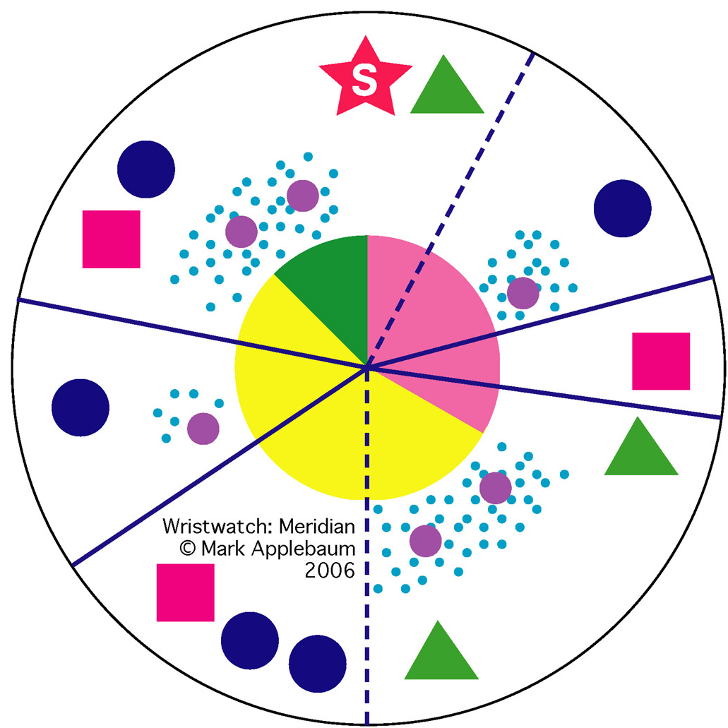

I. The innermost ring looks like a pie chart.

• While the second hand appears within the pink region, players are to vocalize a quiet, continuous
hissing sound.

• While the second hand appears within the yellow region, players are to quietly, but audibly, recite the
seconds as they are attained by the second hand. For example “thirty-three, thirty-four, thirty-five…”

• While the second hand appears within the green region, players are to produce a quiet, continuous
vocal fry.
II. The middle ring consists of fields of small dots within which reside larger dots.

• While the second hand appears within a field of small dots, players are to make quiet lip popping
noises. The pops should be numerous and rhythmically irregular. They need not correspond to
individual dots.

• When the second hand passes a large dot, players are to make a modest percussive noise with the
foot. This can be a stepping or tapping sound with the toe or heel, either on the floor or against an
object or material. The action should appear deliberate (e.g. beyond an inadvertent motion) but not
overly histrionic or enthusiastic.

III. The outermost ring consists of blue circles, green triangles, and pink squares. When the second
hand passes over a…

• circle, players are to play one instrumental note.

• triangle, players are to play three successive instrumental notes in a regular or irregular rhythm.

• square, players are to play four successive instrumental notes in a regular or irregular rhythm.

The notes’ articulation, timbre, register, envelope, etc. are free. The dynamic is also free but should be
more often modest than vociferous.

The pink star with the letter “S” may be interpreted as an invitation to play a brief solo.

IV. Radiating Lines: Meridians.

When the second hand passes a meridian line during the performance of any ring, the player may elect
to insert a brief quotation. Quotations are optional.

• Solid meridians appear four times and suggest the quotation of a short passage, motive, or sound
object found elsewhere in the given concert program.

• Broken (dashed) meridians appear twice and suggest the quotation of a short passage, motive, or
sound object that is not found within the concert program. Moreover, the quotation should contrast
the given concert program in some manner.

* * *

Combination with other Wristwatch pieces. In concert Wristwatch: Meridian may be combined with any other Wristwatch piece, in succession or simultaneously.

Wristwatch: Meridian was originally composed as a part of the musical score Magnetic North for soloist, brass quintet, and optional percussion accompaniment.

